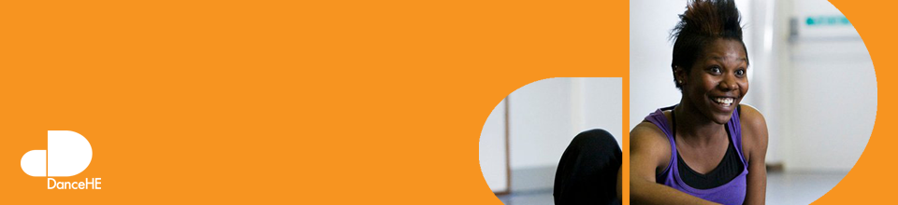
 | Standing Conference for Dance in Higher Education  Northern School of Contemporary Dance Telephone:  Email: Darren.Carr@nscd.ac.uk | Invoice for membership 201617
Invoice #DANHEMEM1617
Date: March 18, 2016

To: (insert your information here)

DESCRIPTION | RATE | AMOUNT
Full institutional membership for DANCE HE | £200.00
Full Individual membership for DANCE HE (per individual) | £100.00
Associate membership for DANCE HE (per individual) | £50.00
 | TOTAL

Make all cheques payable to: Standing Conference for Dance in Higher Education (Dance HE).
Return payment to: Darren Carr (Dance HE), c/o Northern School of Contemporary Dance . 98, Chapeltown Rd, Leeds LS7 4BH.
BACS payment can be made to: Standing Conference for Dance in Higher Education (Dance HE), The Cooperative Bank, P.O.Box 250, Delf House, Southway, Skelmersdale, WN8 6WT. Sort code: 08 92 99 Account number: 65701506
Thank you for your business!

